**Question 1:**

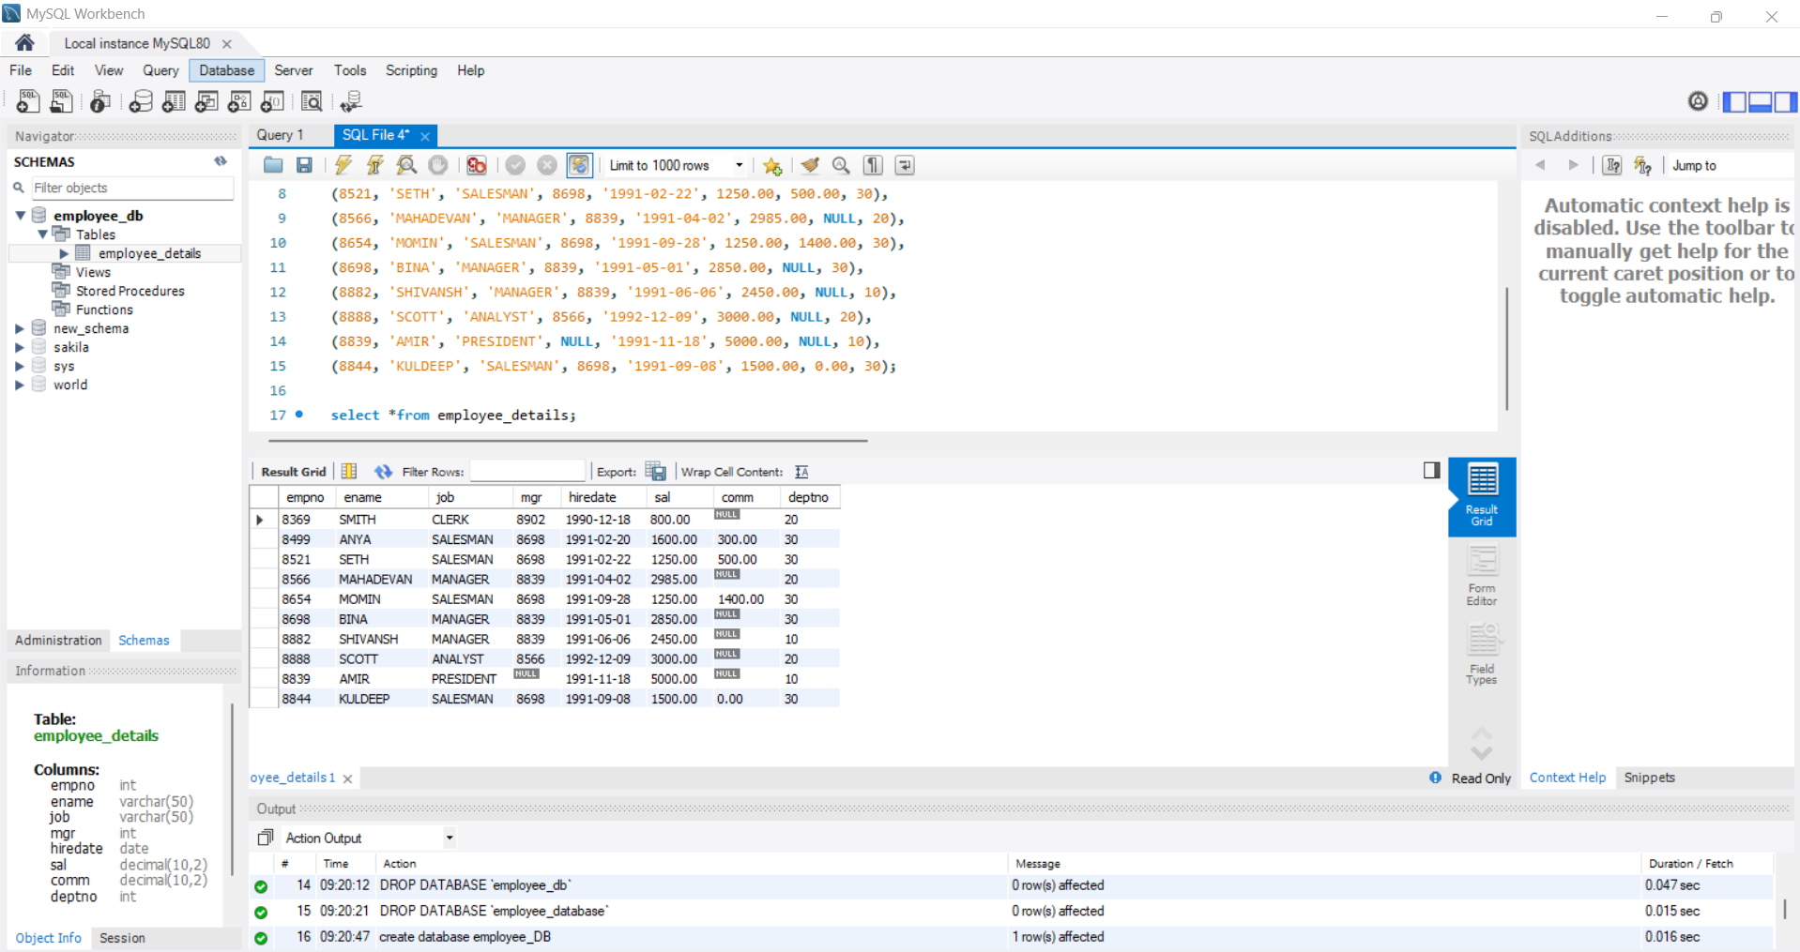

**A. Display ename and sal of employees whose salary is greater than or equal to 2200**

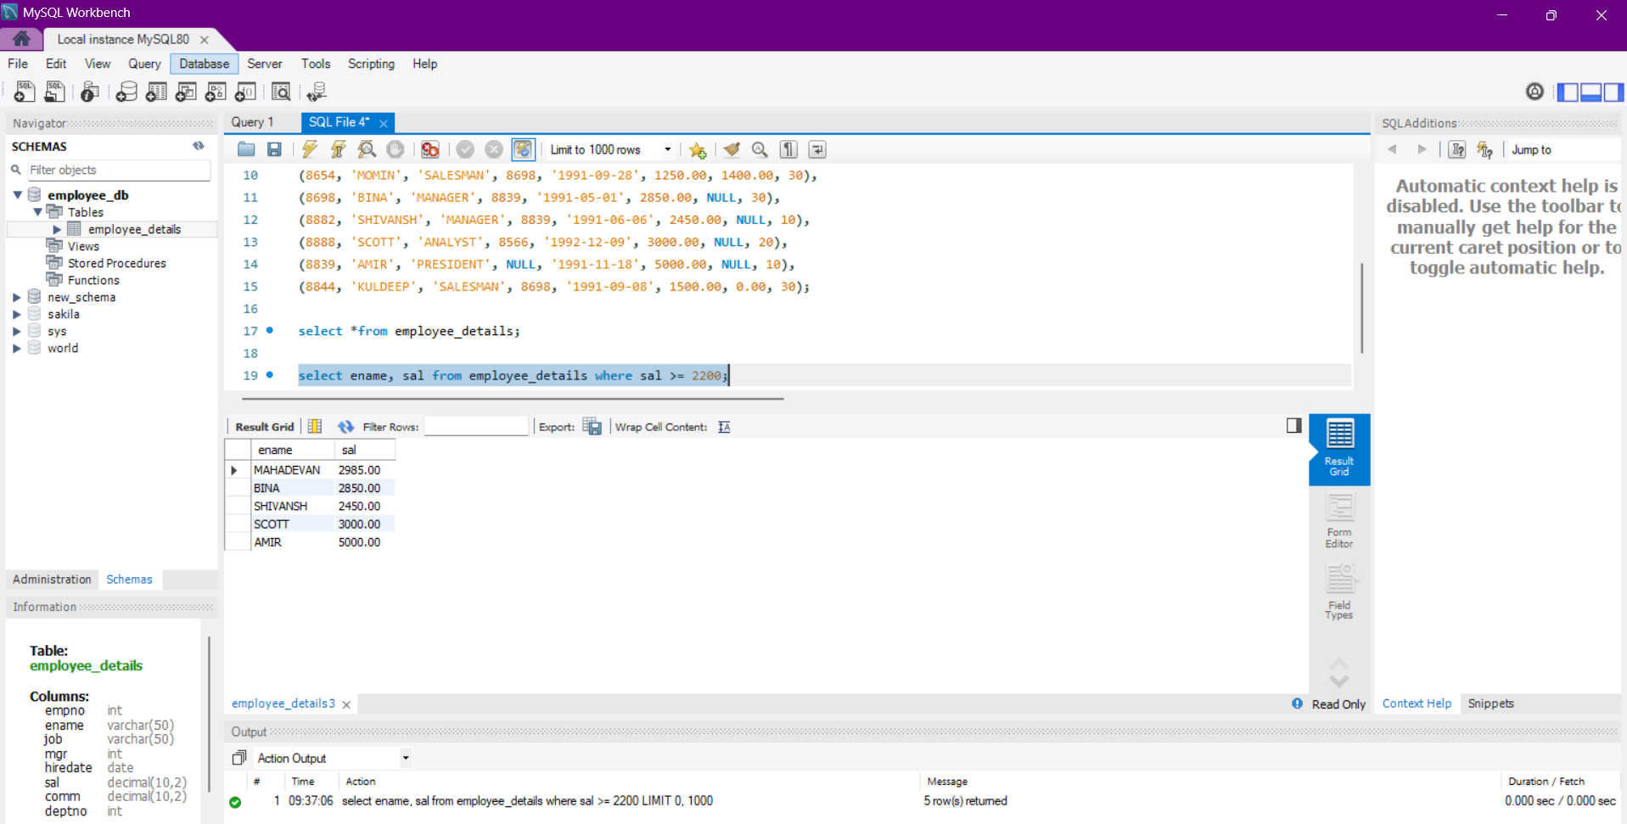

**B. Display details of employees who are not getting commission**

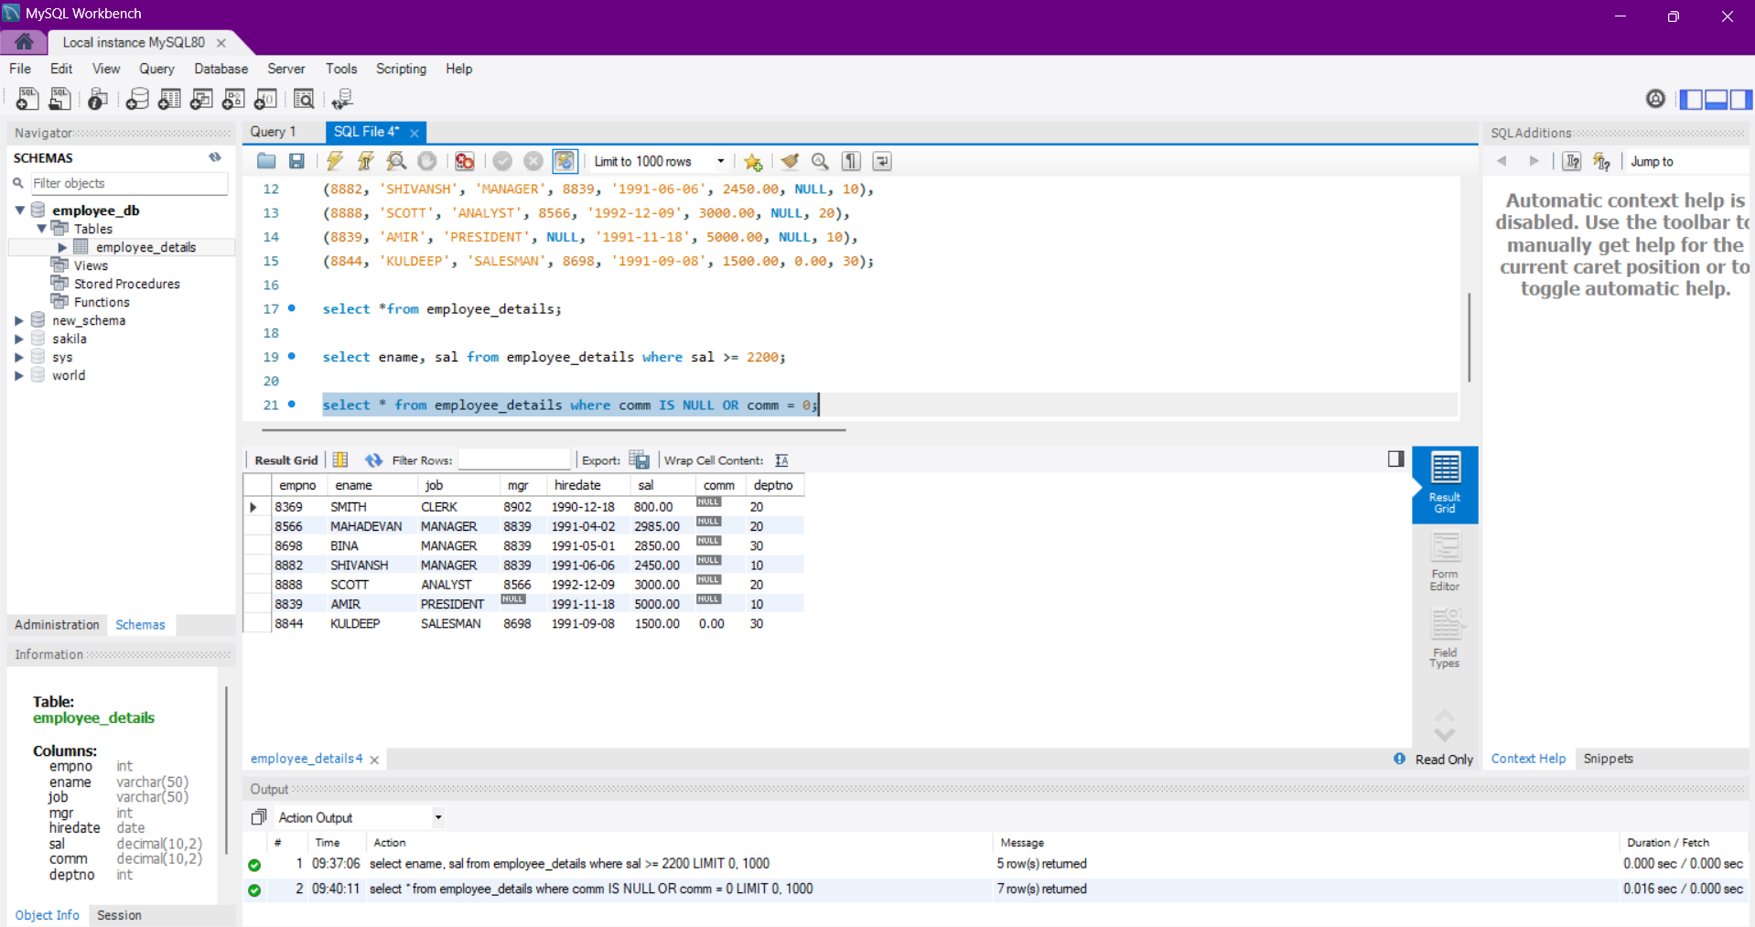

**C. Display ename and sal of employees whose salary is not in the range of 2500 to 4000**

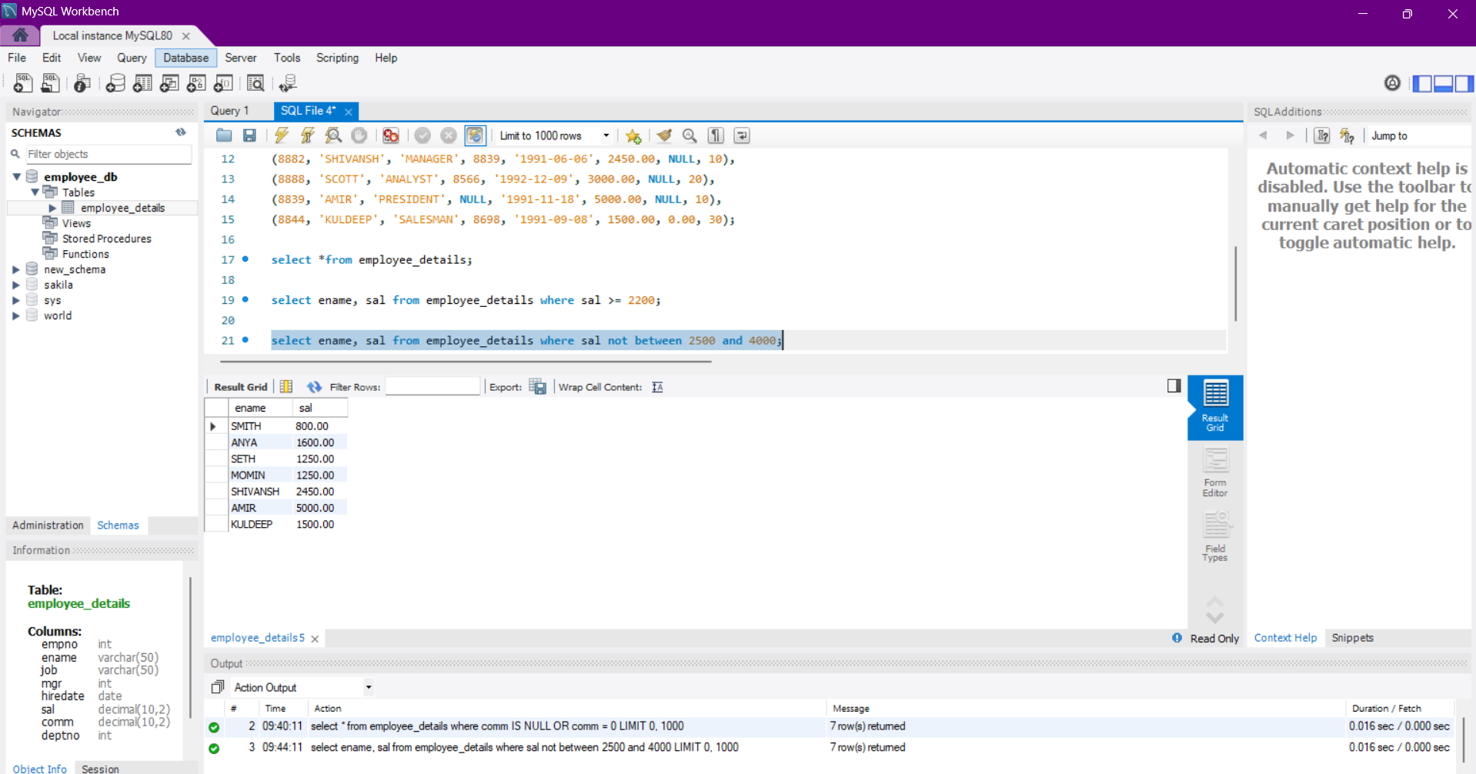

**D. Display the ename, job, and sal of employees who don’t have a manager**

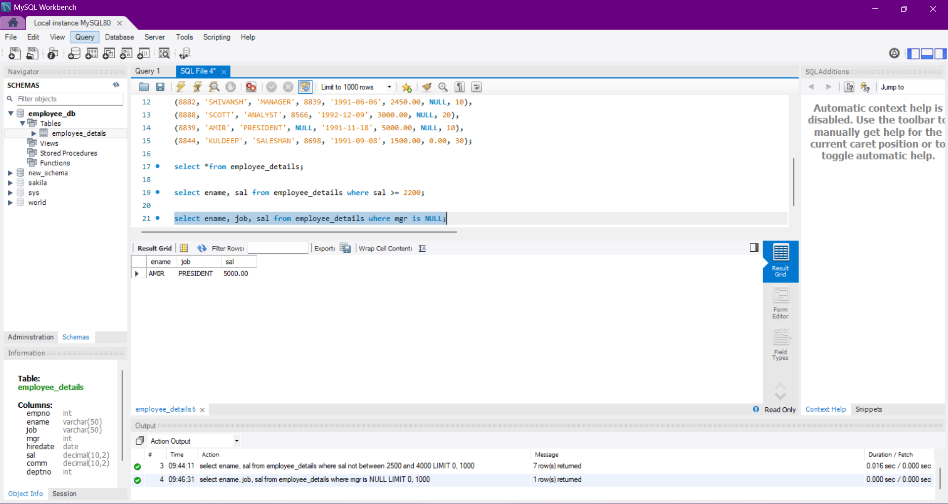

**E. Display the name of employees whose name contains “A” as the third character**

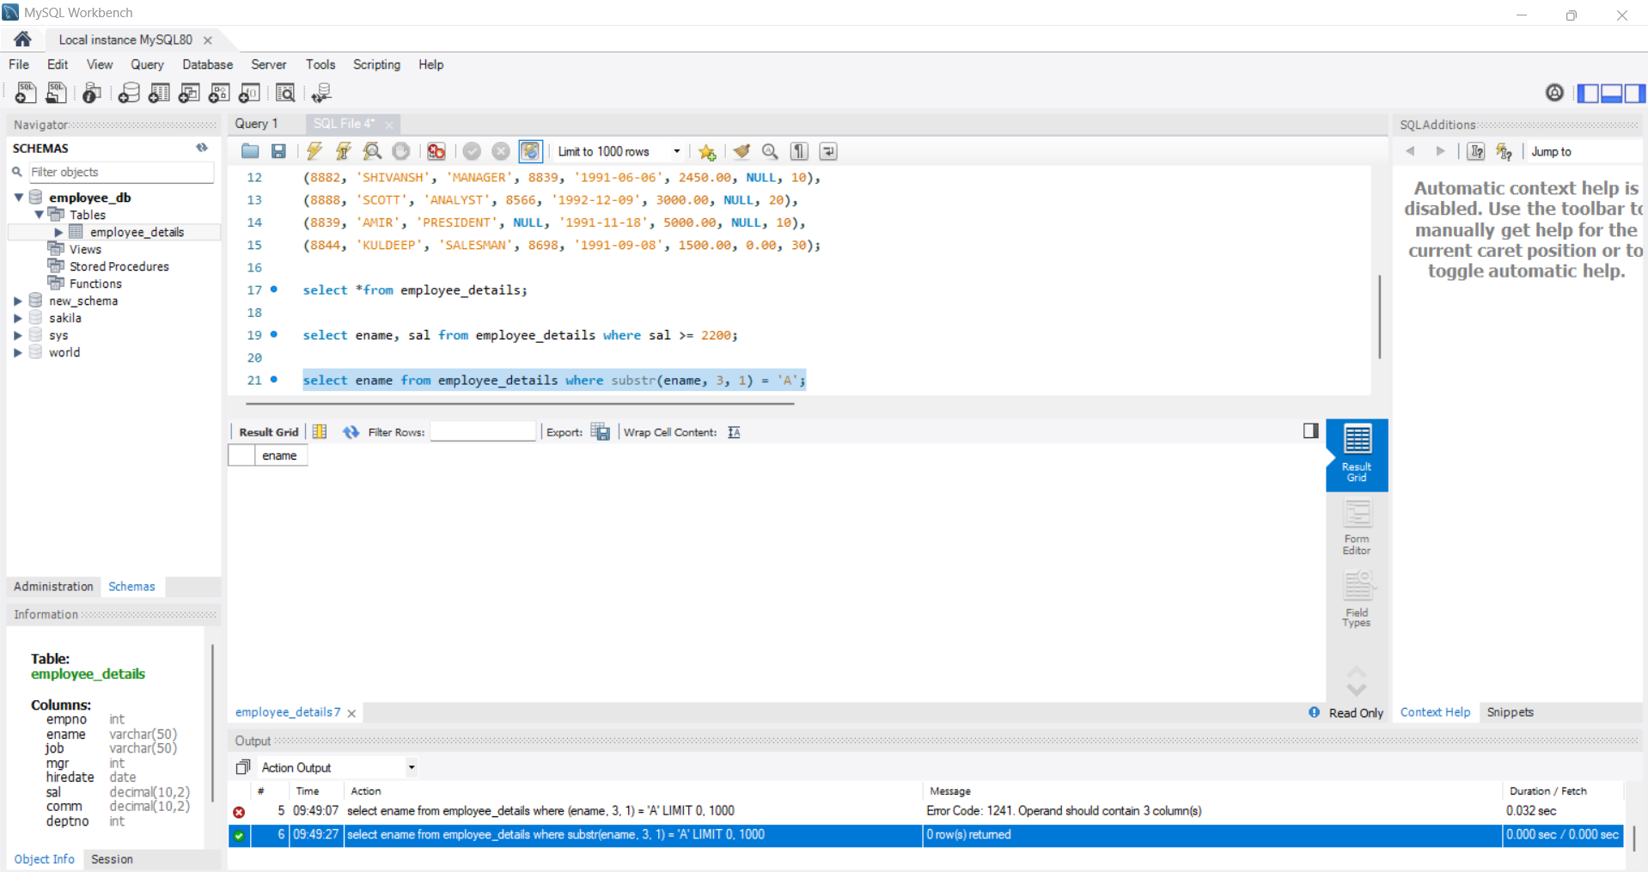

**F. Display the name of employees whose name contains “T” as the last character**

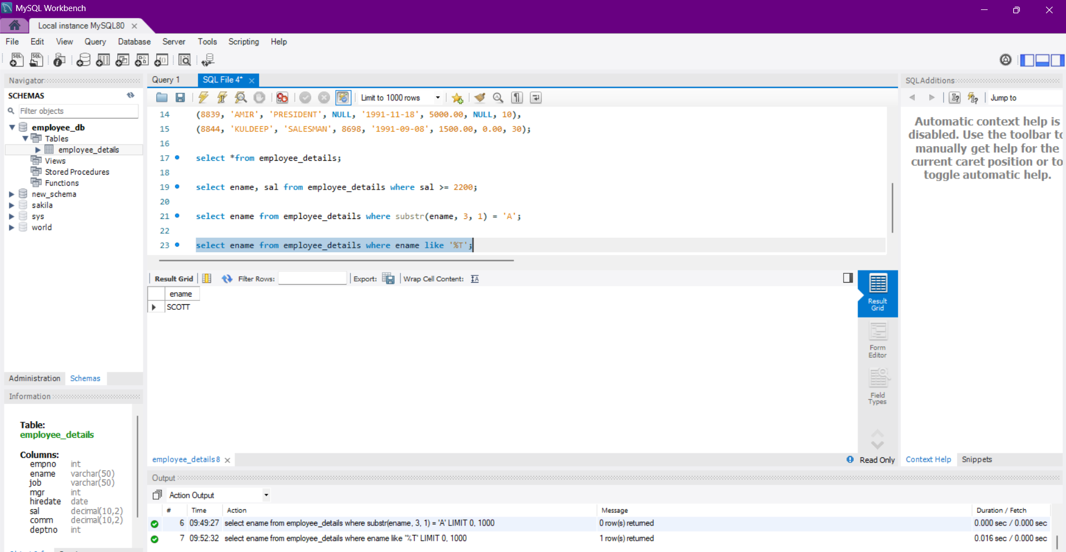

**Question 2:**

